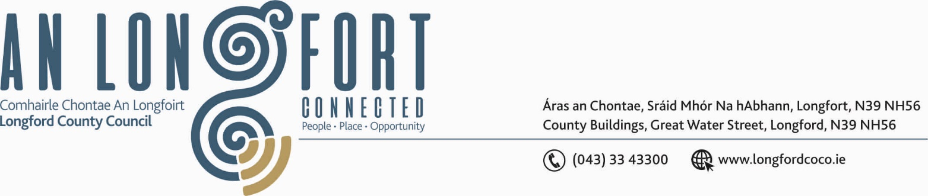

BALLYMAHON MUNICIPAL DISTRICT

23rd October 2018.

To: Each Member of Ballymahon Municipal District.

Dear Member,

You are requested to attend Meeting of Ballymahon Municipal District to be held in Ballymahon Community Library on Monday, 5th November 2018 at 4.30 p.m. to transact business, as set out on the Agenda hereunder.

Yours sincerely,
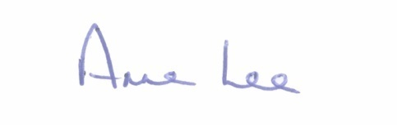

_______________
Anne Lee,
Meetings Administrator.

AGENDA

- Consideration of 2019-2021 Multi-Annual Restoration Improvement Programme.

- Consideration of the 2019 General Municipal Allocation.

